Snickerdoodles 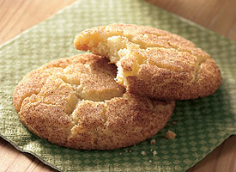They may have an unusual name, but these rich cinnamon-sugar cookies are great for the holidays or anytime you want a tasty cinnamon treat.
Prep Time: 40 minTotal Time: 50 min
Makes: 4 dozen cookies

1/1/2 cups sugar
½ cup butter or margarine, softened
½ cup shortening
2 eggs
2 ¾ cups all-purpose flour
2 teaspoons cream of tartar
1 teaspoon baking soda
¼ teaspoon salt

¼ cup sugar
2 teaspoons ground cinnamon
- Heat oven to 400 degrees F.
- Mix 1 ½ cups sugar, the butter, shortening and eggs in a large bowl. Stir in flour, cream of tartar, baking soda and salt.
- Shape dough into 1 ¼ inch balls. Mix ¼ cup sugar and the cinnamon. Roll balls in cinnamon sugar mixture. Place 2 inches apart on ungreased cookie sheet.
- Bake 8 – 10 minutes or until set. Remove from cookie sheet to wire rack.

Nutrition Information:
1 Serving: Calories 90 (Calories from Fat 35 ); Total Fat 4 g (Saturated Fat 2 g); Cholesterol 15 mg; Sodium 55 mg; Total Carbohydrate 13 g (Dietary Fiber 0g); Protein 1 g Percent Daily Value*: Vitamin A 0%; Vitamin C 2 %; Calcium 0%; Iron 2 % Exchanges: 1 Starch
*Percent Daily Values are based on a 2,000 calorie diet.

Cookie Evaluation
- How did your cookies turn out? Be specific?

- Did everyone’s cookies turn out the same or differently? What did some groups do right or wrong?

- What would you do differently next time?

